People Counter Over-view

So first of all we going to detect the person using Yolov8 model, and our main goal is to detect the peron in front of the door, so we need to draw our region of interest area.

So we will draw our region of interest using “cv2.polylines method”. Furthermore, we want to detect our object only if it is in our interest area.

Then we will count how many person entering the hotel and how many person exiting the hotel.

So now how are drawing Regoin of interest ??

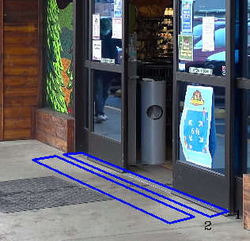
region of interest

We are using “mouse function” to get the (x,y) co-ordinate of cursor in the given frame:

def RGB(event, x, y, flags, param):
if event == cv2.EVENT_MOUSEMOVE :
colorsBGR = [x, y]
print(colorsBGR)

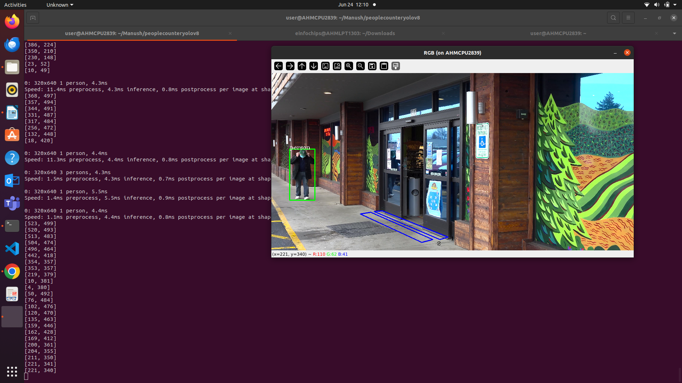
co-ordinate value

now by using these values we are creating our areas of interest:

area1=[(312,388),(289,390),(474,469),(497,462)]

area2=[(279,392),(250,397),(423,477),(454,469)]

Then we are drawing our regoin of interest using “cv2.polyline” function as follows:

cv2.polylines(frame,[np.array(area1,np.int32)],True,(255,0,0),2)
cv2.putText(frame,str('1'),(504,471),cv2.FONT_HERSHEY_COMPLEX,(0.5),(0,0,0),1)

cv2.polylines(frame,[np.array(area2,np.int32)],True,(255,0,0),2)
cv2.putText(frame,str('2'),(466,485),cv2.FONT_HERSHEY_COMPLEX,(0.5),(0,0,0),1)

Now we are creating a pink circle at the right-most corner of rectangle :
cv2.circle(frame, (x2,y2), 5, (255,0,255), -1)
reason for creating a pink-circle is that if circle lies in area2 then only we want to detect our object (in our case object is person). Moreover if that circle is in area1, we are not going to detect that object.

Now we are using “pointPolygonTest” method, purpose of this is if right-most circle or point is in area2 then it prints 1 or number greater than or equal to 0.
results = cv2.pointPolygonTest(np.array(area2,np.int32), ((x2,y2)), False)
print(results)

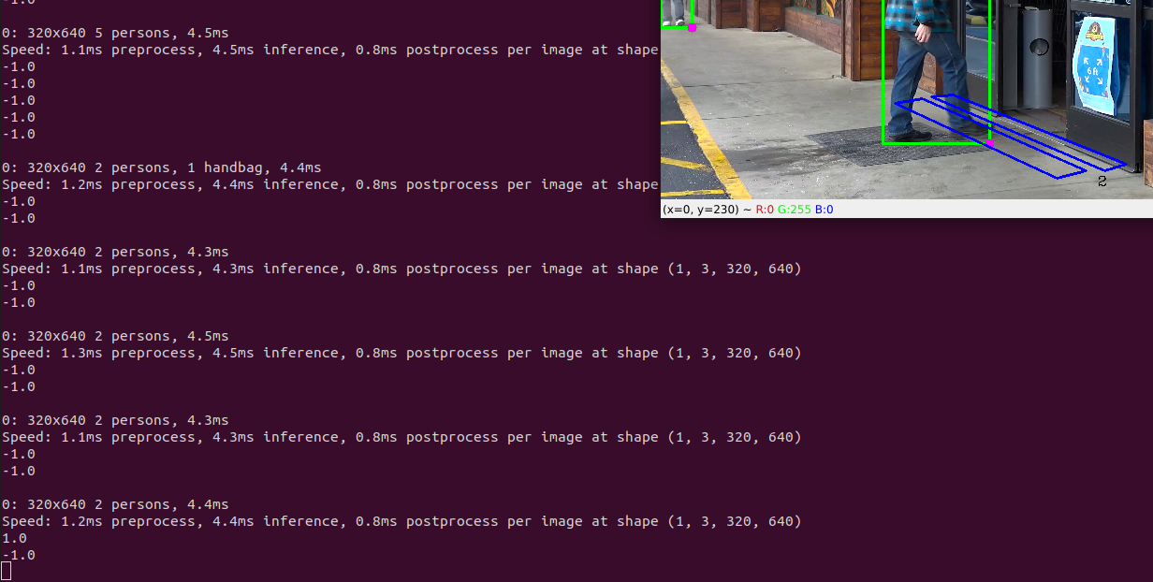

Below code snippet is basically, if right-most point is in area2 then only we want to detect our object/person.

if 'person' in c:
results = cv2.pointPolygonTest(np.array(area2,np.int32), ((x2,y2)), False)
if results >= 0:
cv2.rectangle(frame,(x1,y1),(x2,y2),(0,255,0),2)
cv2.circle(frame, (x2,y2), 5, (255,0,255), -1) # we are marking a pink circle at rightmost corner of rectangle
cv2.putText(frame,str(c),(x1,y1),cv2.FONT_HERSHEY_COMPLEX,(0.5),(255,255,255),1)

Now we are using tracker.py to assign unique-id to each person/reactangle:
First for-loop detects the person and appends it to list.
After the first for-loop we are getting unique-ids.
for index,row in px.iterrows():
# print(row)
# this all are object/person co-ordinates, basically rectangle
x1=int(row[0])
y1=int(row[1])
x2=int(row[2])
y2=int(row[3])
d=int(row[5])
c=class_list[d] # "d" is basically class-id
if 'person' in c:
list.append([x1, y1, x2, y2])

bbox_id = tracker.update(list)
for bbox in bbox_id:
#getting new co-ordinates for reactangle we are passing with a uinque-id
x3, y3, x4, y4, id = bbox
results = cv2.pointPolygonTest(np.array(area2,np.int32), ((x4,y4)), False)
if results >= 0:
cv2.rectangle(frame,(x3,y3),(x4,y4),(0,255,0),2)
cv2.circle(frame, (x4,y4), 5, (255,0,255), -1) # we are marking a pink circle at rightmost corner of rectangle
cv2.putText(frame,str(id),(x3,y3),cv2.FONT_HERSHEY_COMPLEX,(0.5),(255,255,255),1)

Now we want to count how many persons are going inside the hotel and how many are leaving the hotel.
So for entering --> person needs to be part of area2 first and then area1.
For leaving --> person needs to be part of area1 first and then area2.

So for entering, if person is in area2 then we will save it’s current position and id in dictionary.

people_entering[id] = (x4, y4)

For entering the hotel, when both the conditions are met, area2 then area1, we will save the id in “entering set”.

